PROGRAM 10

/\* Program to use switch(break) \*/

#include <stdio.h>

int main()

{

int i;

double number, sum = 0.0;

for (i = 1; i <= 10; ++i)

{

printf("Enter a n%d: ", i);

scanf("%lf", &number);

if (number < 0.0)

{

break;

}

sum += number;

}

printf("Sum = %.2lf", sum);

return 0;

}

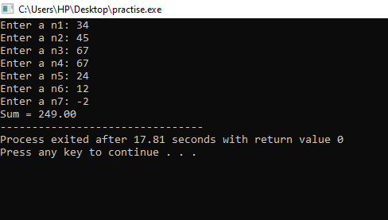

/\* Program to demonstrate switch statement(continue) \*/

#include <stdio.h>

int main()

{

int i;

double number, sum = 0.0;

for (i = 1; i <= 10; ++i)

{

printf("Enter a n%d: ", i);

scanf("%lf", &number);

if (number < 0.0)

{

continue;

}

sum += number;

}

printf("Sum = %.2lf", sum);

return 0;

}

